## Advance JavaScript assignment

**MODULE: 1 (Introduction and Code Quality)**

Q-1 Write a program to Show an alert?

A-1

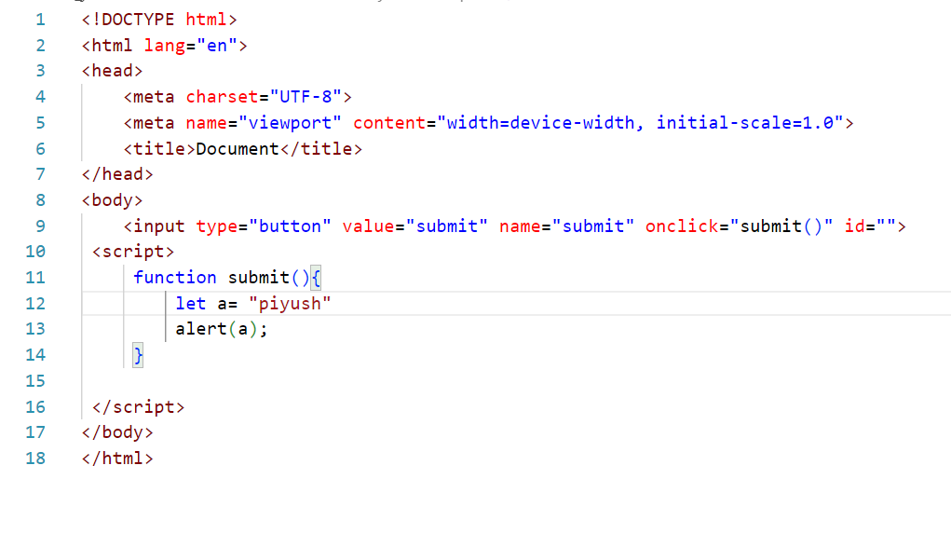

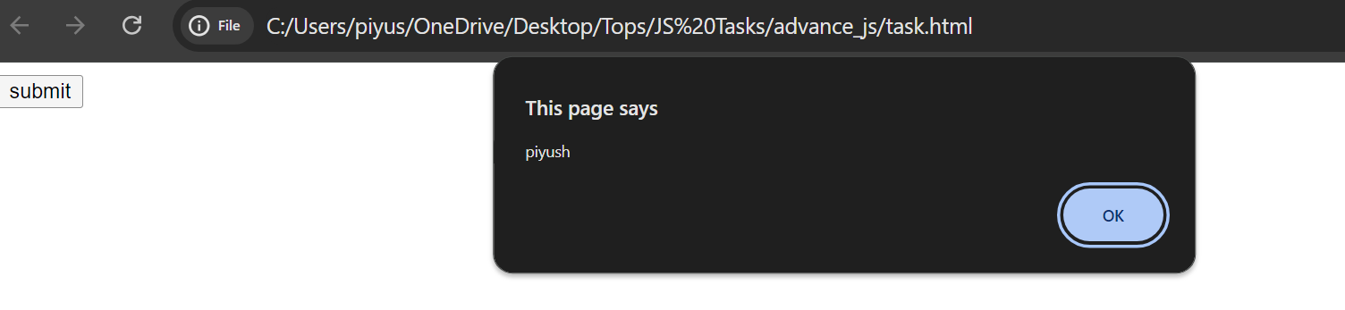

Q.2 What will be the result for these expressions?

(1) 5 > 4

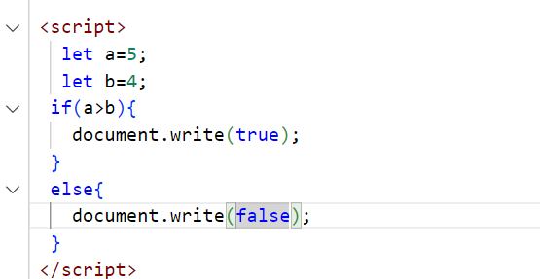

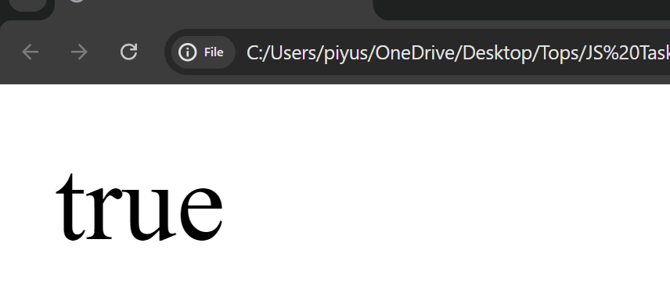

(2) . "apple" > "pineapple"

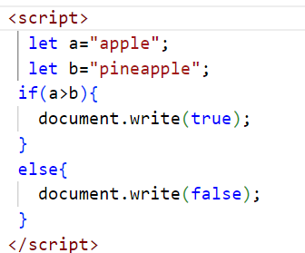

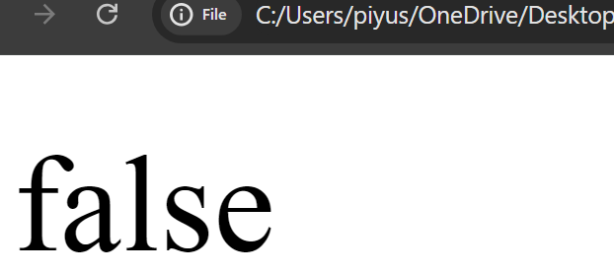

(3) “2" > "12"

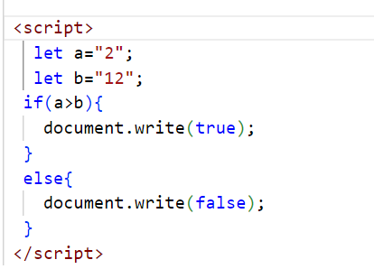

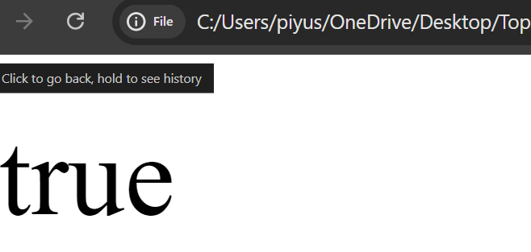

(4) undefined == null

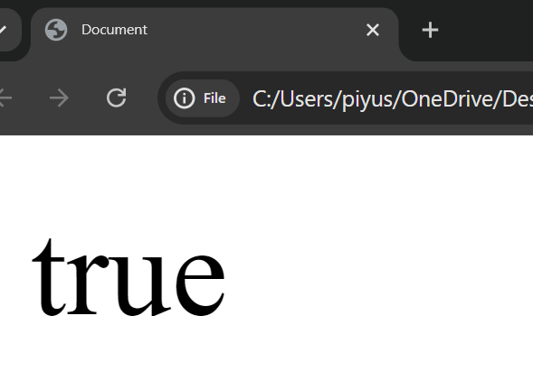

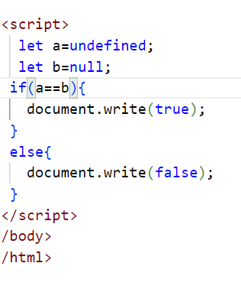

(5) undefined === null

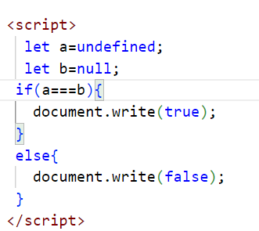

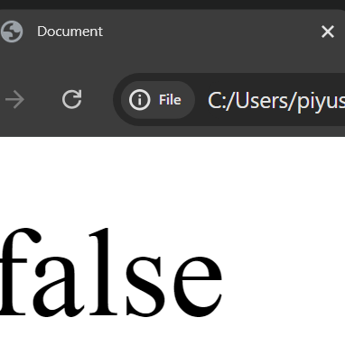

(6) null == "\n0\n"

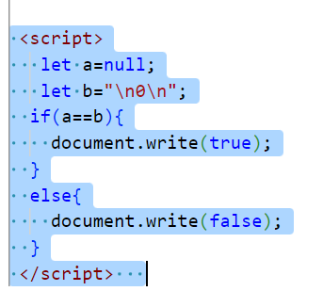

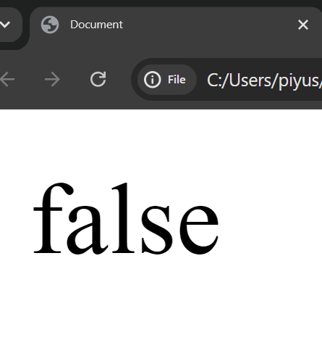

(7) null === +"\n0\n"

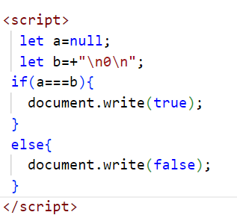

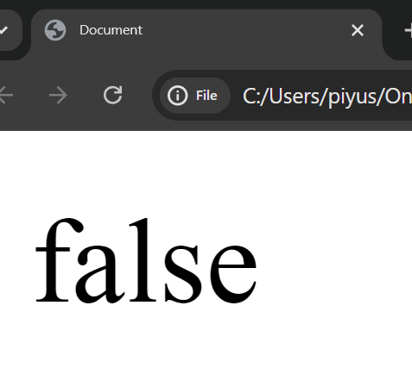

Q-3 Will alert be shown? 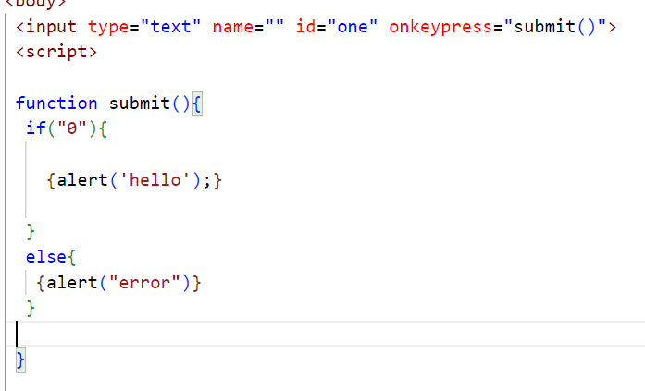

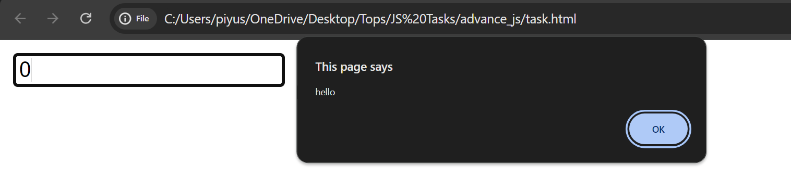

Q-4 What is the code below going to output?

alert (null || 2 || undefined);

A-4

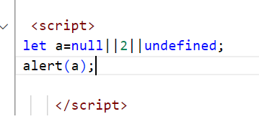

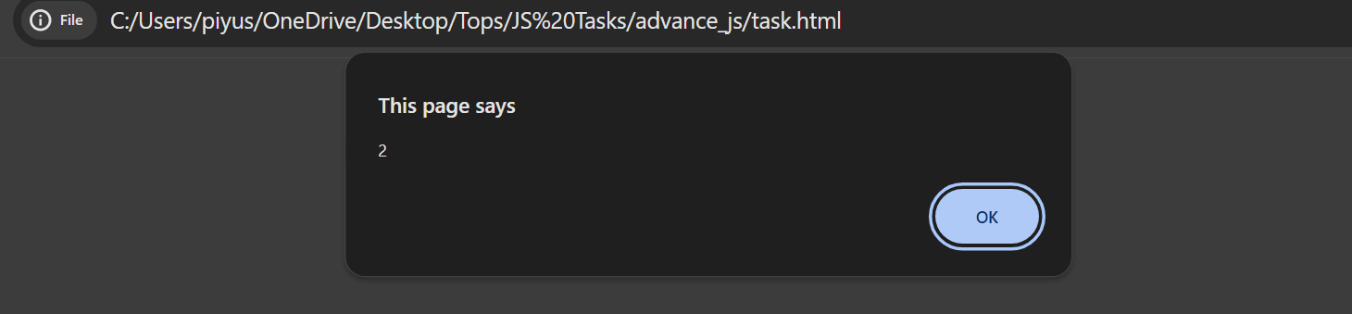

Q-5-The following function returns true if the parameter age is greater than 18. xOtherwise, it asks for a confirmation and returns its result:

Ans-5

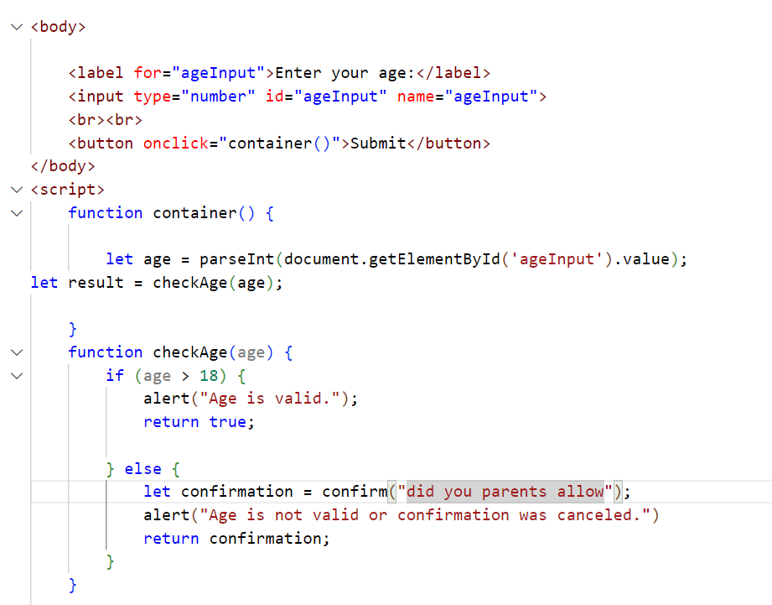

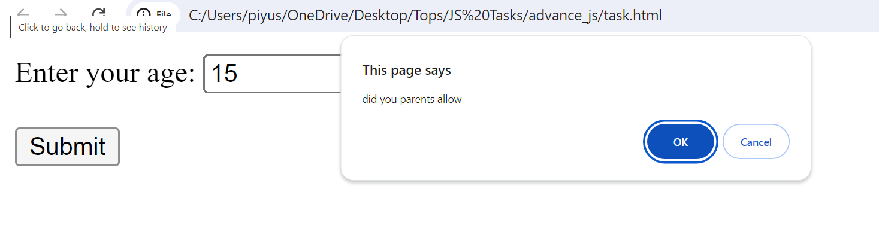

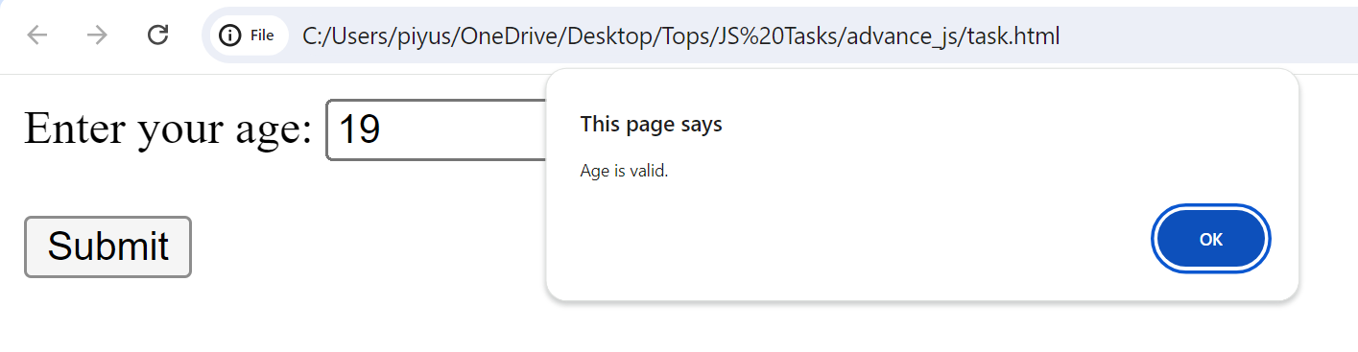

Q-6 Replace Function Expressions with arrow functions in the code below

Ans-6

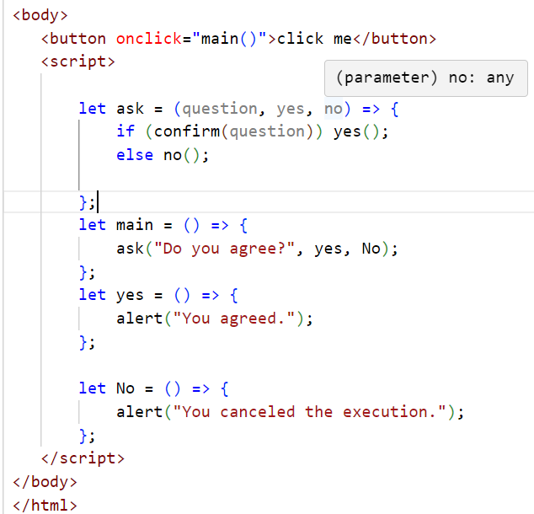

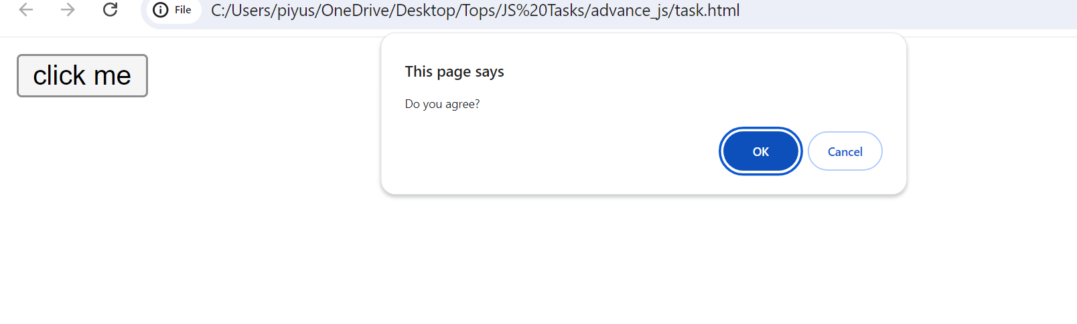

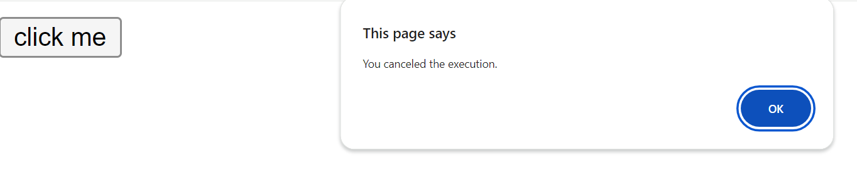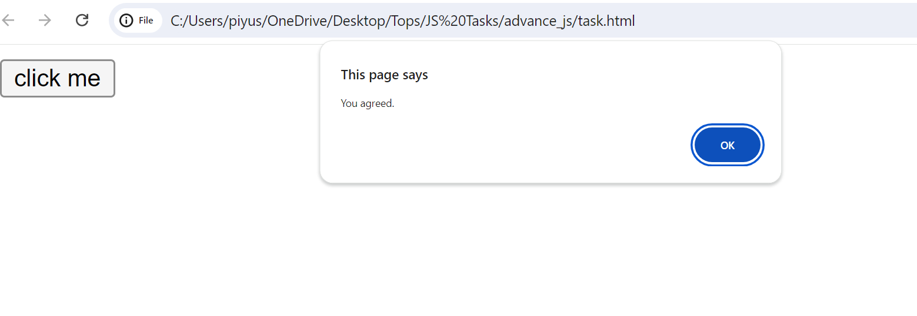

**MODULE: 2 (Data Types and Objects)**

Write the code, one line for each action:

1. Create an empty object user:

=> let user = {};

b) Add the property name with the value John.

=> let user = {};

    user.name = 'John';

c)Add the property surname with the value Smith.

=> let user = {};

    user.name = 'John';

user. Surname = 'Smith';

d) Change the value of the name to Pete

=> let user = {};

    user.name = 'Pete';

e) Remove the property name from the object.

=> let user = {};

    user.name = 'John';

    delete user.name;

Q.2 Is array copied? let fruits = ["Apples", "Pear", "Orange"]; // push a new value into the "copy" let shopping Cart = fruits; shoppingCart.push("Banana"); // what's in fruits? alert (fruits. Length); //?

Ans2

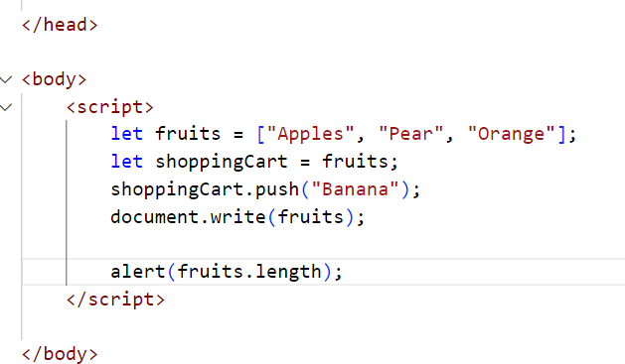

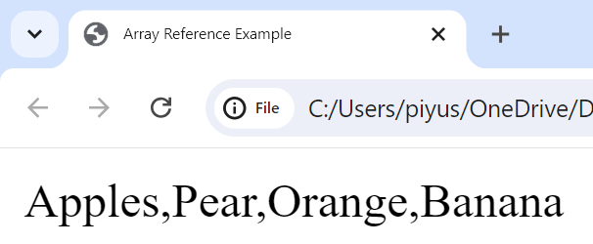

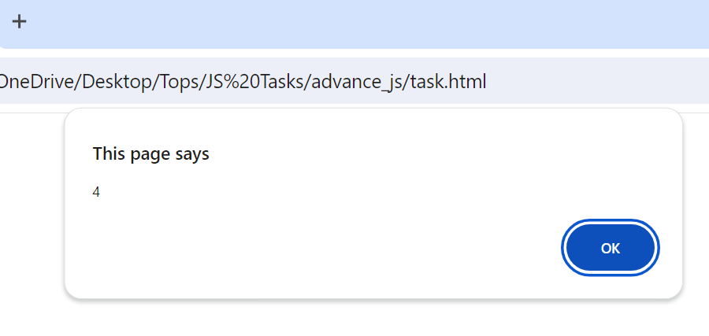

Q-3Map to names let john = { name: "John", age: 25 }; let pete = { name: "Pete", age: 30 }; let mary = { name: "Mary", age: 28 }; let users = [ john, pete, mary ]; let names = /* ... your code */ alert( names ); // John, Pete, Mary.

Ans-3

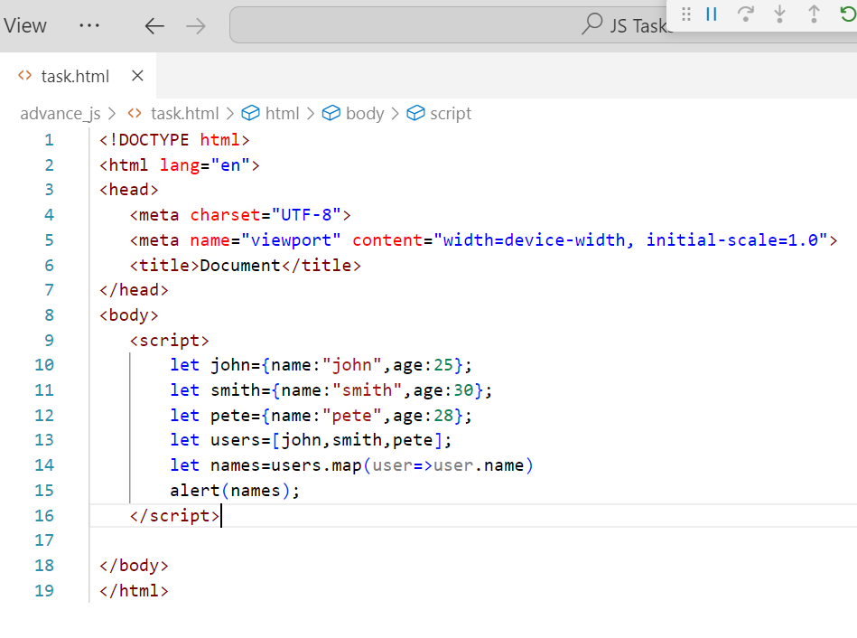

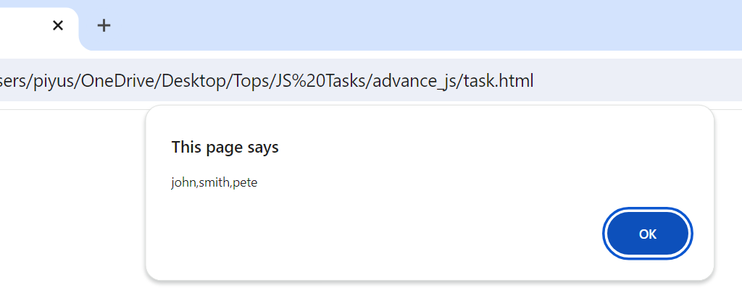

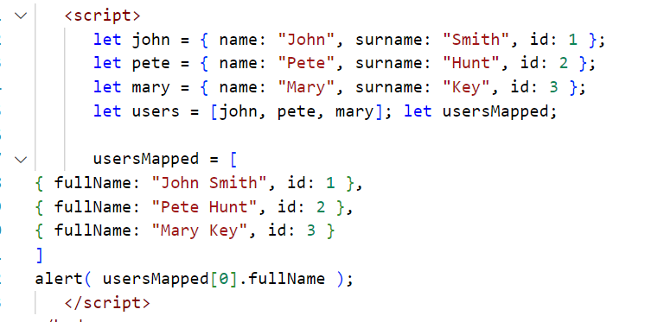

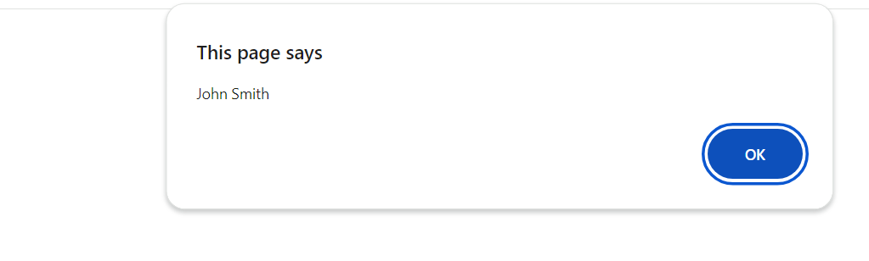

Q-4 Sum the properties There is a salaries object with arbitrary number of salaries. Write the function sum salaries(salaries) that returns the sum of all salaries using Object. Values and the for..of loop.If salaries is empty, then the result must be 0. let salaries = { "John": 100, "Pete": 300, "Mary": 250 }; alert( sumSalaries(salaries) ); // 650

Ans-4 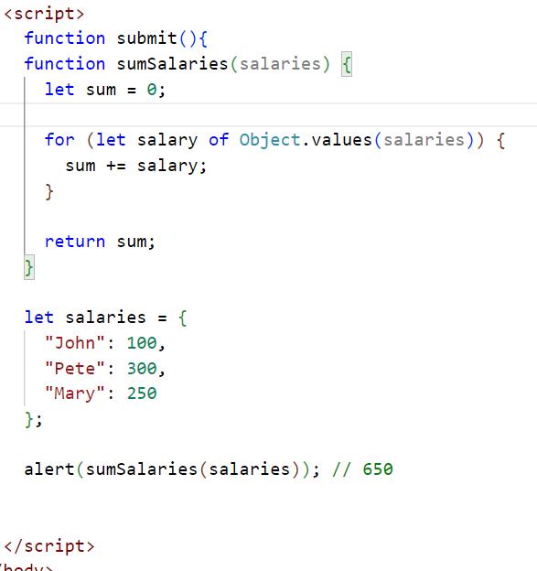

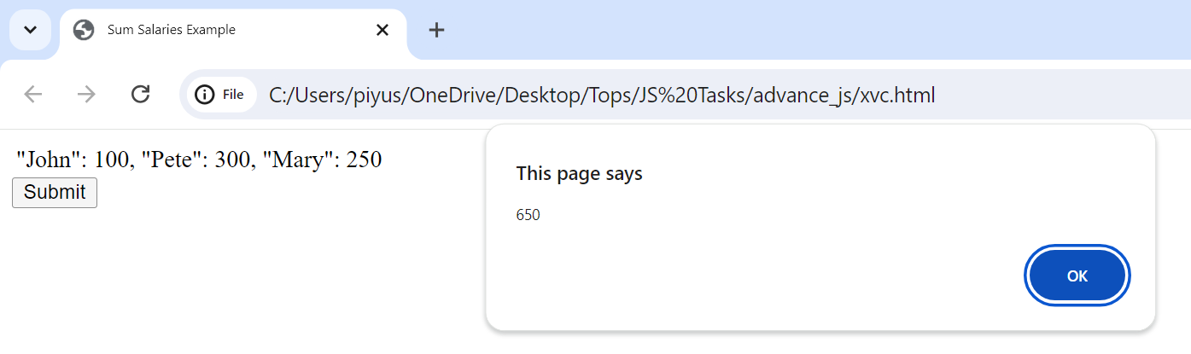

Q-5 DE structuring assignment We have an object: Write the DE structuring assignment that reads:

a) Name property into the variable name.

1. Year’s property into the variable age.
2. isAdmin property into the variable isAdmin (false, if no such property)
3. d) let user = { name: "John", years: 30};

Ans-5 :

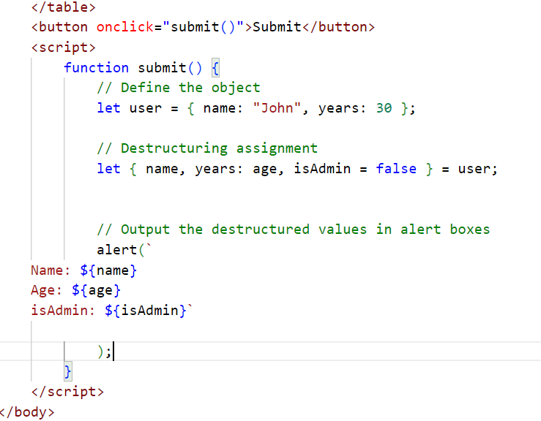

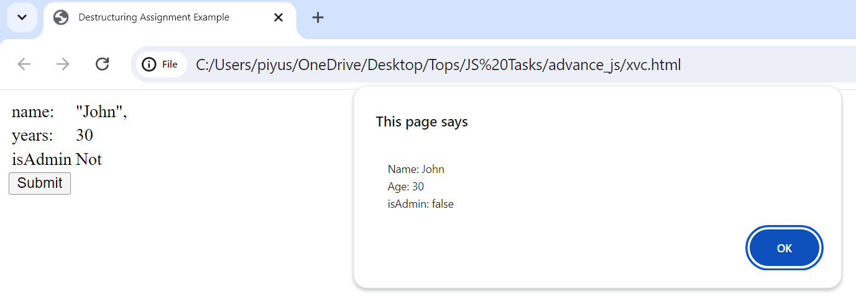

Q-6 Turn the object into JSON and back Turn the user into JSON and then read it back into another variable.

user = { name: "John Smith", age: 35};

Ans-6

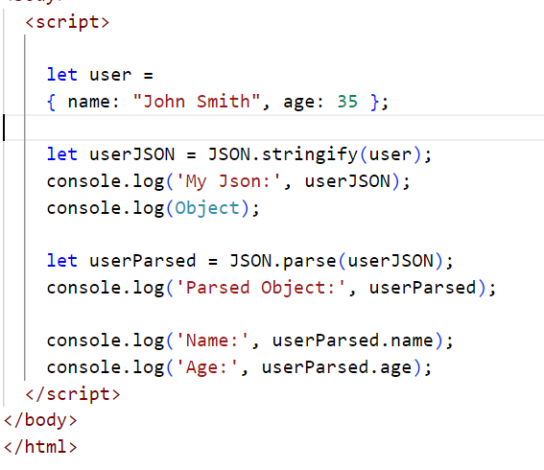

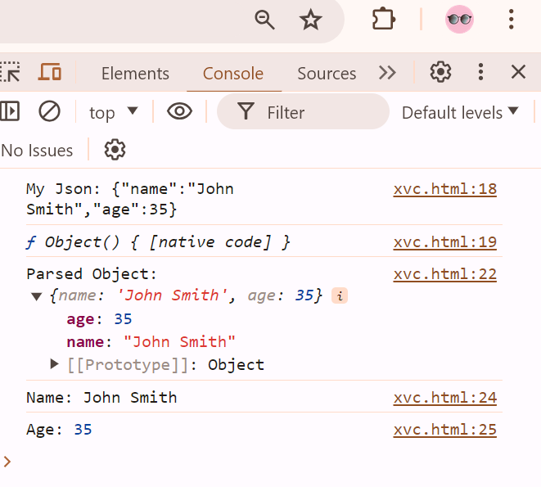

**MODULE: 3 (Document, Event and Controls)**

Q-1 Create a program to hide/show the password?

A-1

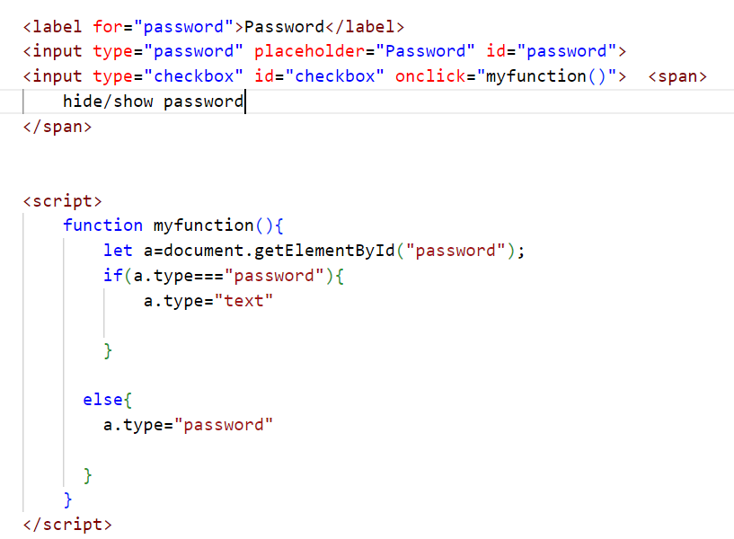

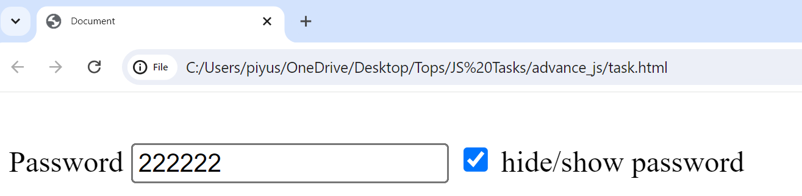

Q-2 Create a program that will select all the classes and loop over and whenever i click the button the alert should show.

Ans-

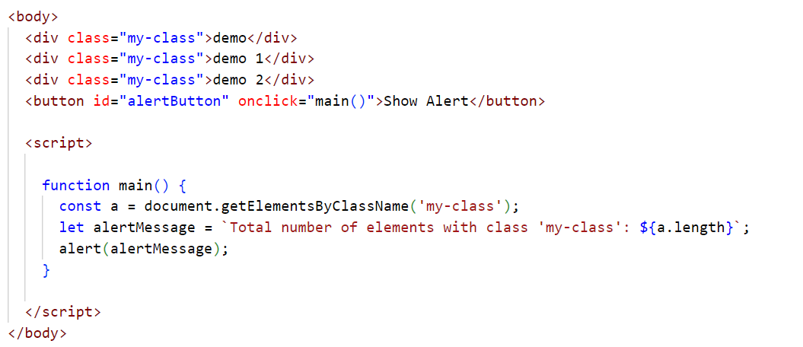

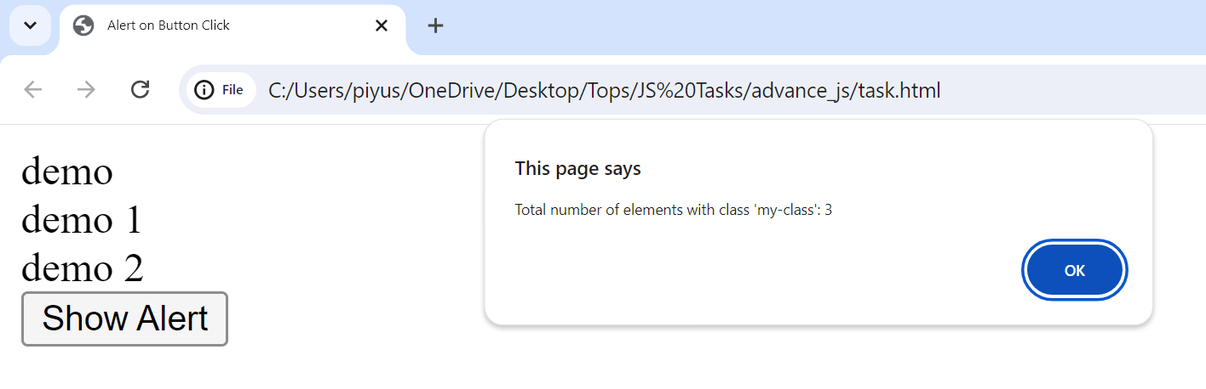

Q-3 Create a responsive header using proper JavaScript.

Ans-3

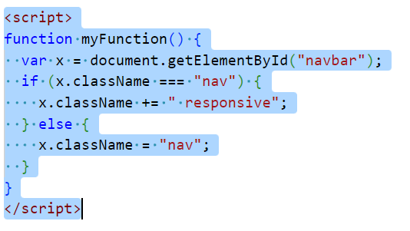

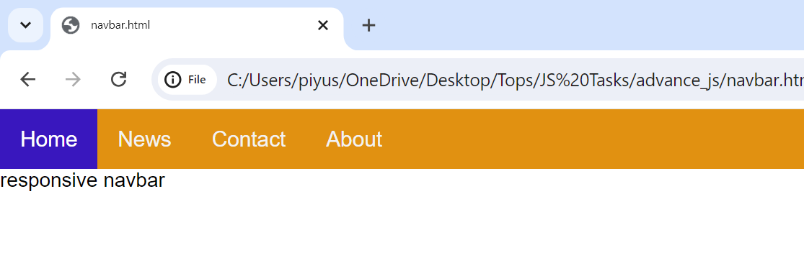

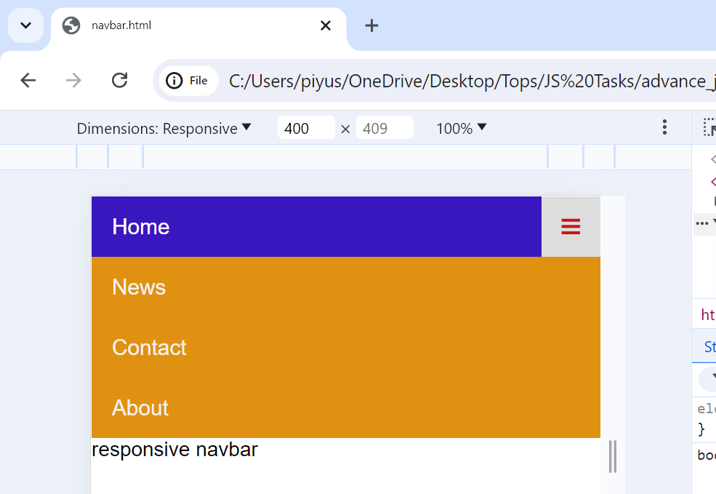

Q-4 Create a form and validate using JavaScript.

Ans-4

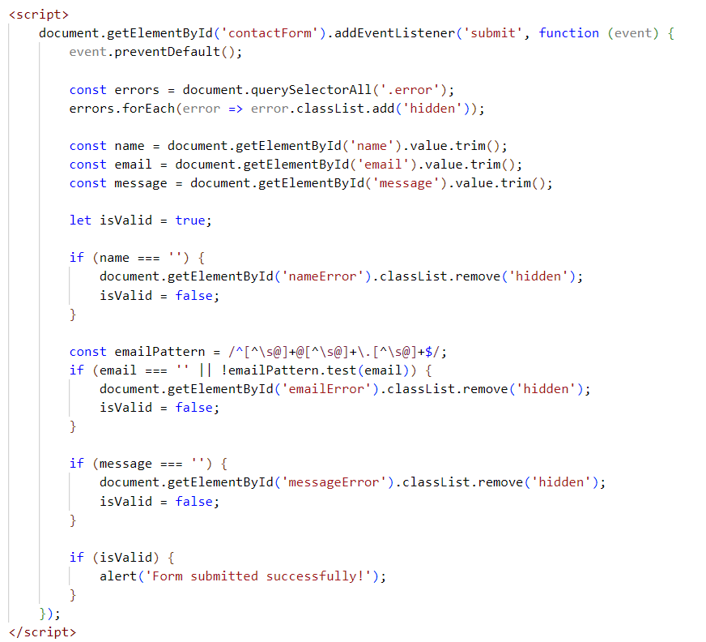

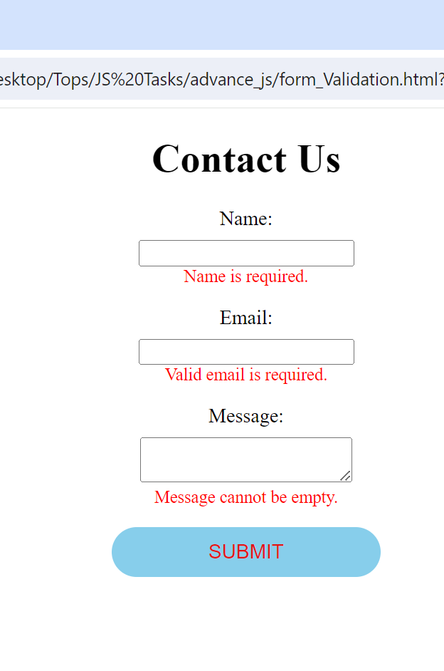

Q-5 Create a modal box using css and Js with three buttons.

Ans- 5

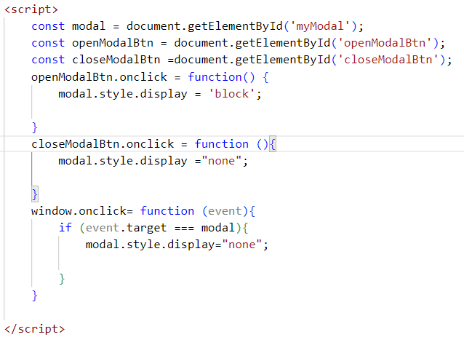

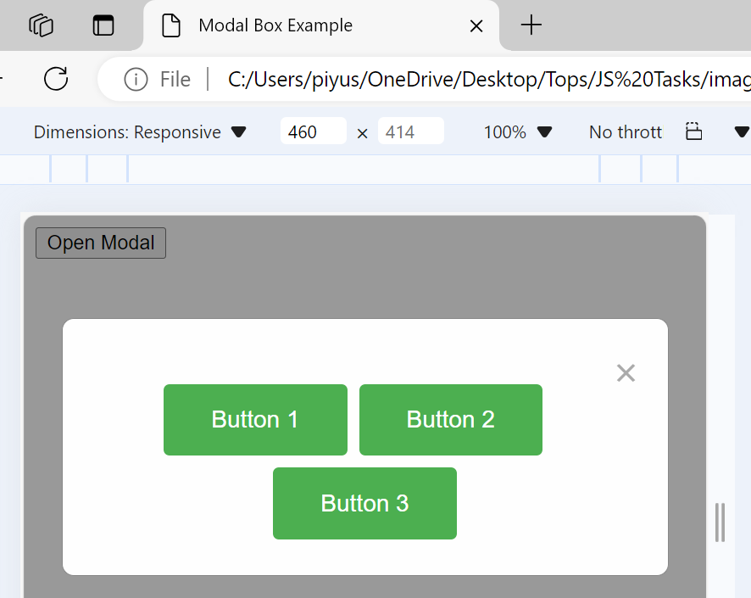

Q-6 Use external js library to show slider.

Ans-6

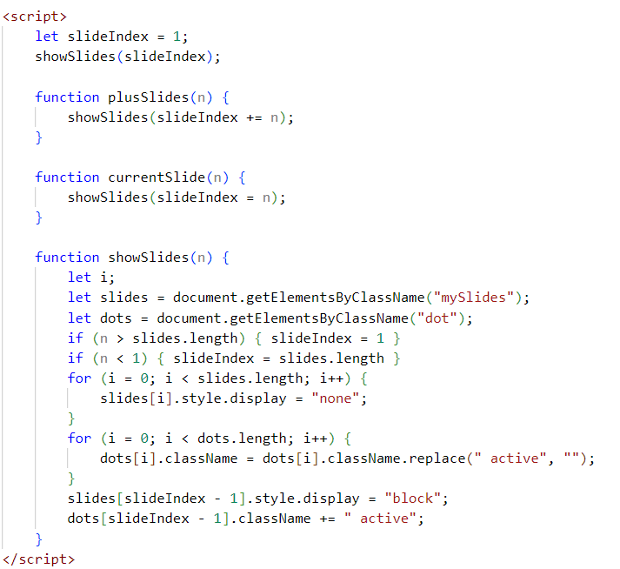

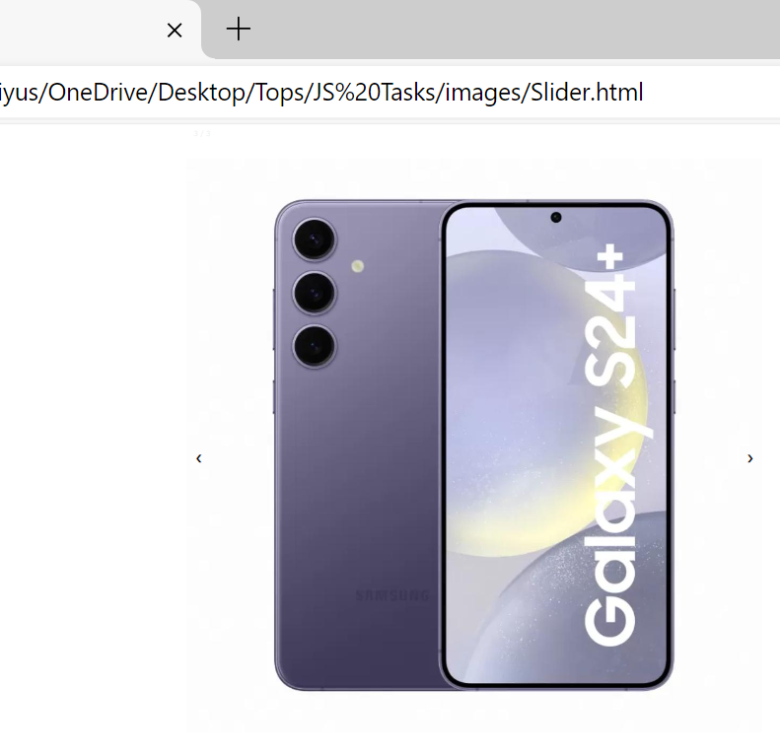

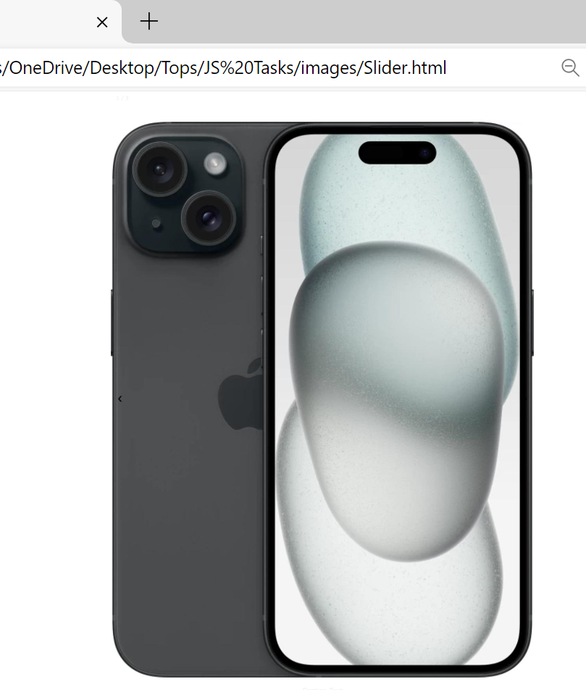

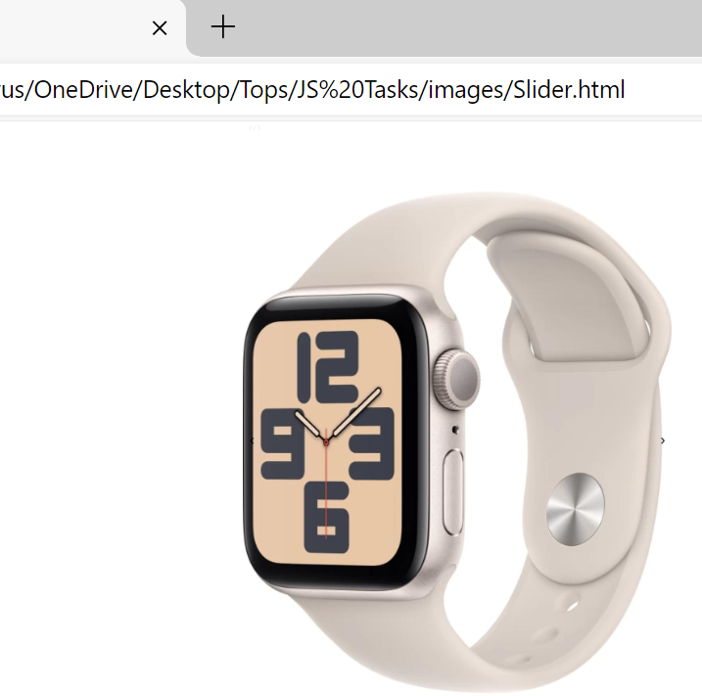

Q-7 Prevent the browser when i click the form submit button.

Ans-7

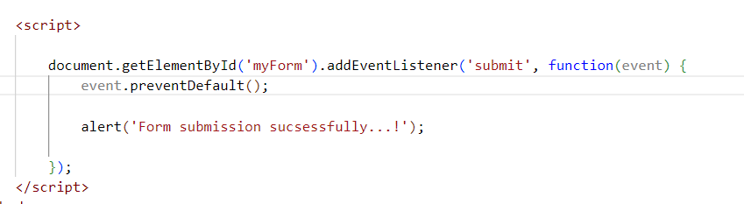

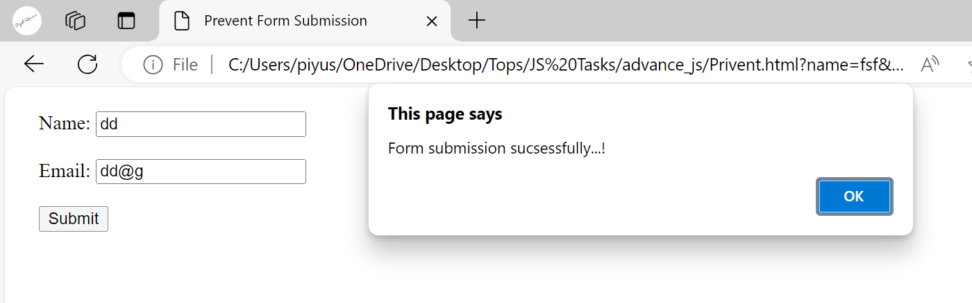

**MODULE: 4 (New Request)**

**Q-1 What is JSON.**

**Ans-1**

* **Json is a JavaScript object notation**
* **Json is alight-weight data**
* **=>Json is a interchange format so easy for human read and write**
* **Json is a transfer data between a server and web application**
* **Json is build in two structures**
* **1)object**
* **2) arrays**
* **Example of Json**

**"first Name": "John",**

**"last Name": "Doe",**

**"age": 30,**

**Q-2 What is promises.**

**Ans-**

* **Promises are a fundamental concept in JavaScript used for handling asynchronous operations.**
* **They provide a more structured way to deal with asynchronous code compared to traditional callback functions.**
* **Characteristics of Promises:**
* **Asynchronous Operations**
* **state**
* **Chaining**

**Q-3 Write a program of promises and handle that promises also.**

**Ans-3**

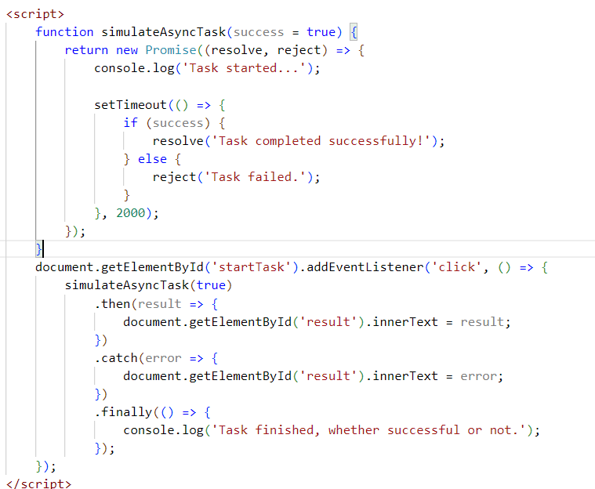

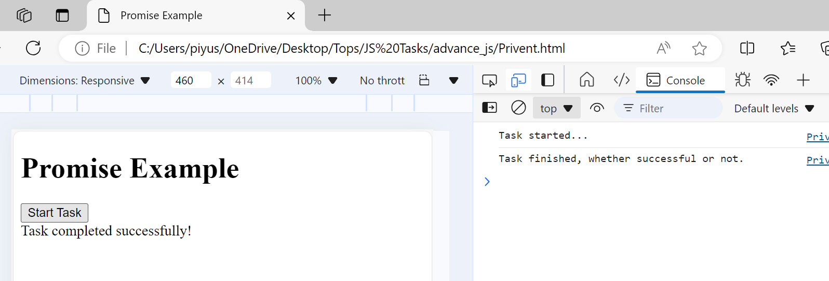

**Q-4 Use fetch method for calling an api** [**https://fakestoreapi.com/products**](https://fakestoreapi.com/products)

**Ans-4**

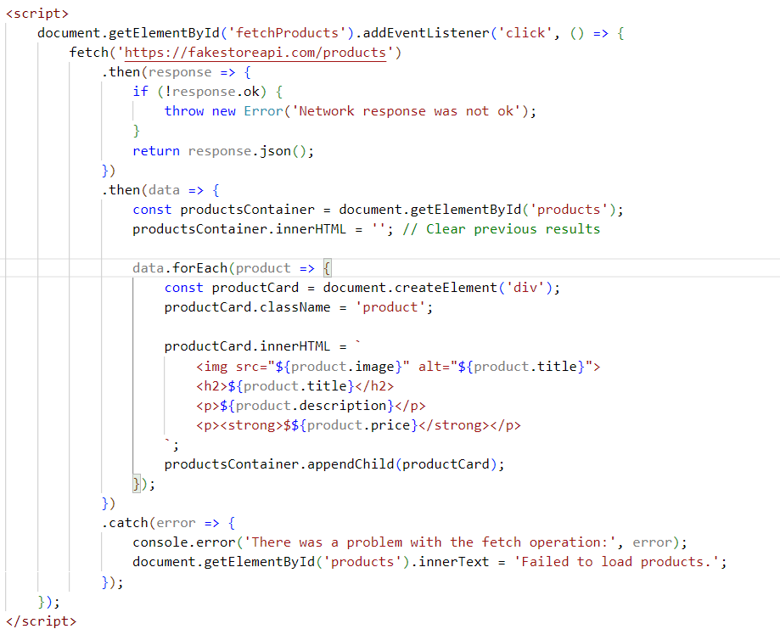

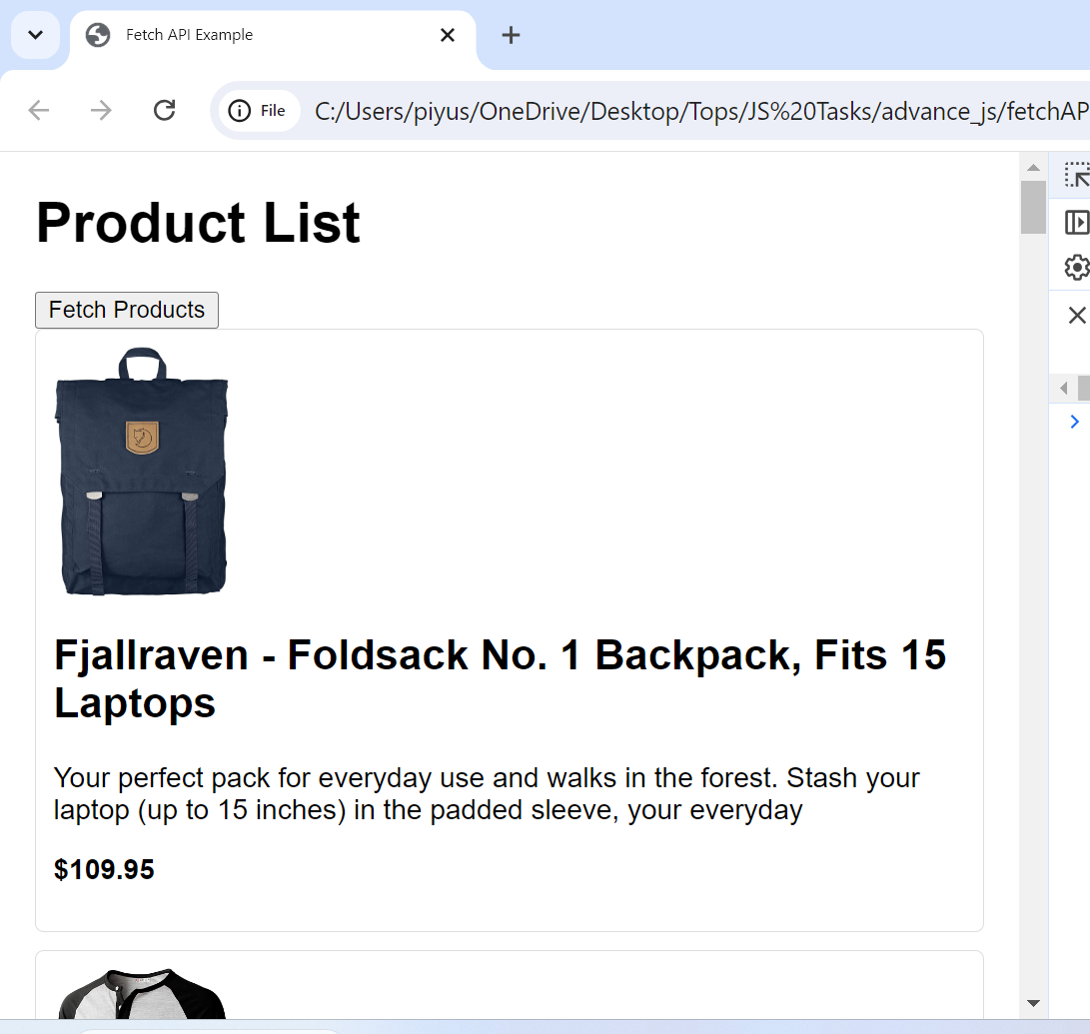

**Q-5 Display all the product from the api in your HTML page.**

**Ans-5**

